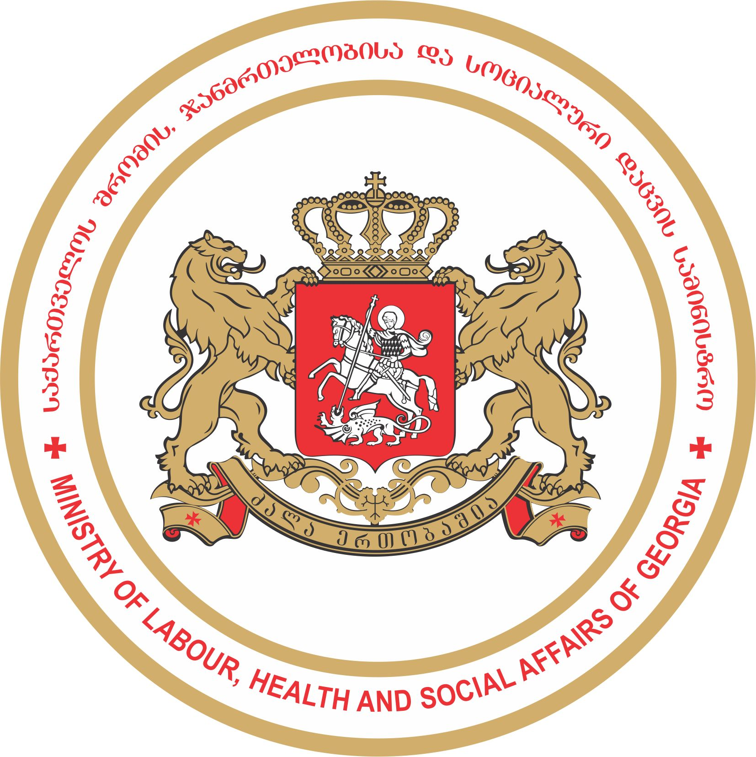
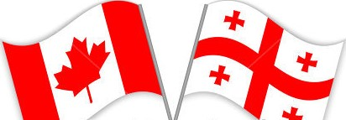
საქართველოს შრომის, ჯანმრთელობისა და

სოციალური დაცვის

მინისტრის მოადგილის ბატონი მიხეილ დუნდუას ვიზიტი კანადაში

The Visit of the First Deputy Minister of

Health, Labour and Social Affairs of Georgia Mr. Mikheil Dundua to Canada

AGENDA

Meeting Schedule

23/07/2018 – 27/07/2018

Members of the Delegation:

Deputy Minister Mikheil Dundua;
ENGLISH VERSION
July 23, 2018
18:00 – Arrive in Toronto Pearson International Airport

July 24, 2018
11:00 – 14:00 – Meeting with the Member of the Parliament Hon. Arif Virani. Venue: Parkdale – High Park Office

19:00 – 22:00 – Dinner with Hon. Virani. Venue: Old Mill Restaurant

July 25, 2018
11:00 – 13:00 – Meeting with Ms. Diana Cooke, Mr. , Trevor McAlmont, Office of Ontario Child Advocate. Venue: 401 Bay Street, Suite 2010

13:00 – 14:00 – Lunch with Ms. Cooke and Mr. McAlmont. Venue: Miller Tavern

15:30 – 17:00 – Meeting with Dr. Shaheen Azmi, Ms. Shafiza Gangji, Ontario Human Rights Commission, Venue: 180 Dundas Street West, Suite 900

19:00 – 22:00 – Dinner with Dr. Azmi and Ms. Gangji. Venue: Georgia Restaurant

July 26, 2018
15:00 – 16:00 – Meeting with Ministry of Justice and Attorneys specializing on children’s rights in Ottawa. Venue: TBD

19:00 – 22:00 – Dinner with Hon. Bob Rae, Liberal Party of Canada. Venue: TBD

July 27, 2018
22:30 – Depart Toronto Pearson International Airport

